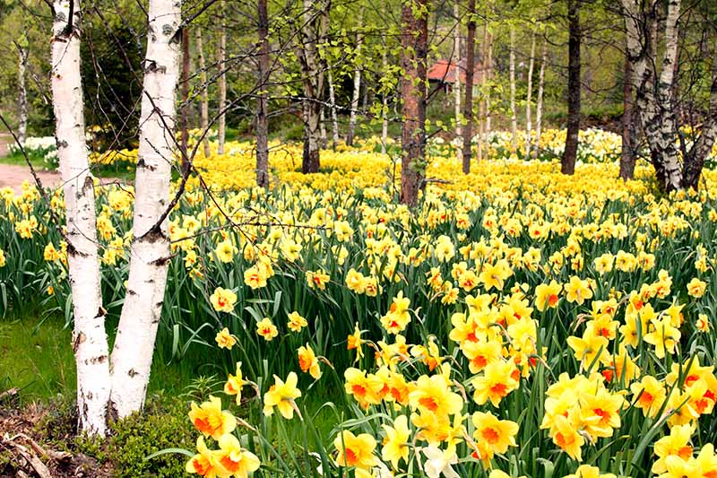

Naturalizing Daffodils is a technique that can bring great beauty and effortless charm. It allows the bulbs to thrive and spread naturally and create bloom year after year.

We have many varieties of quality bulbs from our local growers, offering great value for money in 25kg at from **£20 per net.**

**Yellow Daffodils-**

LOT 8157 California 10

LOT 8157 California 10/12

LOT 8165 California 12/14

LOT 8169 California 14+

LOT 8187 Carlton 10

LOT 8191 Carlton 10/12

LOT 8227 Dutch Master 10

LOT 8327 Golden Anniversary 10/12

LOT 8787 St Keverne 10/12

LOT 8791 St Keverne 12/14

LOT 8793 St Keverne 12/14

LOT 8795 St Keverne 14+

LOT 9901 St Keverne 14/16

LOT 8817 Tamara 10 (£16)

LOT 8821 Tamara 10/12 (£16)

LOT 8829 Tamara 14+ (£16)

LOT 8846 Veryan 12/14 (£16)

**Yellow/Orange Daffodils**

LOT 8291 Fortune 12/14

LOT 8300 Fortune 14+